Database Structure Document

Table of Contents

**ER Diagram 3**

**Normalization 4**

First Normal Form (1NF) 4

Second Normal Form (2NF) 5

**Table Structures 7**

# ER Diagram

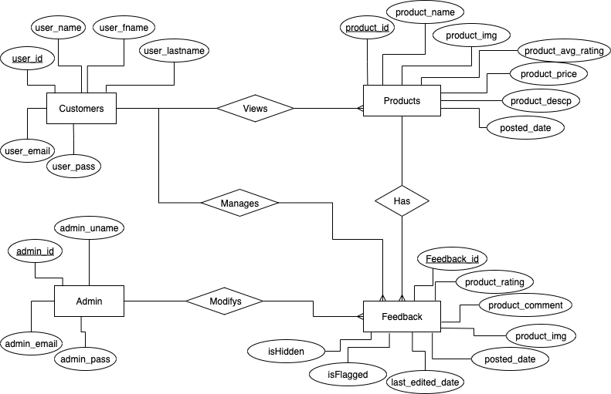

# Normalization

## First Normal Form (1NF)

**Admin Table - adminTable:**

* admin_id PRIMARY KEY NOT NULL INT,
* admin_uname varchar(15),
* admin_email varchar(100),
* admin_pass varchar(10)

**Customer Table - userTable:**

* user_id PRIMARY KEY NOT NULL INT,
* user_name varchar(15),
* user_fname varchar(20),
* user_lname varchar(20),
* user_email varchar(100),
* user_pass varchar(10),
* feedback_id INT,
* product_id INT,
* FOREIGN KEY(product_id) REFERENCES **productsTable**(product_id)
* FOREIGN KEY(feedback_id) REFERENCES **feedbacksTable**(feedback_id)

**Products Table - productsTable:**

* products_id PRIMARY KEY NOT NULL INT,
* product_name varchar(250),
* product_image varbinary(max),
* product_avg_rating double,
* product_price double,
* product_descp varchar(1000),
* posted_date datetime,
* feedback_id INT,
* product_rating INT,
* product_comment varchar(200),
* FOREIGN KEY(feedback_id) REFERENCES **feedbacksTable**(feedback_id)

**Feedback List - feedbacksTable:**

* feedback_id PRIMARY KEY NOT NULL INT,
* user_id INT,
* user_name varchar(15),
* product_id INT,
* product_name varchar(250),
* product_rating INT,
* product_comment varchar(200),
* product_img varbinary(max)
* posted_date datetime,
* last_edited date datetime,
* isFlagged boolean,
* isHidden boolean
* FOREIGN KEY(user_id) REFERENCES **userTable**(user_id)
* FOREIGN KEY(product_id) REFERENCES **productsTable**(product_id)

## Second Normal Form (2NF)

**Customer Table - userTable:**

* user_id PRIMARY KEY NOT NULL INT,
* user_name varchar(15),
* user_fname varchar(20),
* user_lname varchar(20),
* user_email varchar(100),
* user_pass varchar(10),

**Products Table - productsTable:**

* products_id PRIMARY KEY NOT NULL INT,
* product_name varchar(250),
* product_image varbinary(max),
* product_avg_rating double,
* product_price double,
* product_descp varchar(1000),
* posted_date datetime,

**Feedback List - feedbacksTable:**

* feedback_id PRIMARY KEY NOT NULL INT,
* user_id INT,
* product_id INT,
* product_rating INT,
* product_comment varchar(200),
* product_img varbinary(max)
* posted_date datetime,
* last_edited date datetime,
* isFlagged boolean,
* isHidden boolean
* FOREIGN KEY(user_id) REFERENCES **userTable**(user_id)
* FOREIGN KEY(product_id) REFERENCES **productsTable**(product_id)

# Table Structures

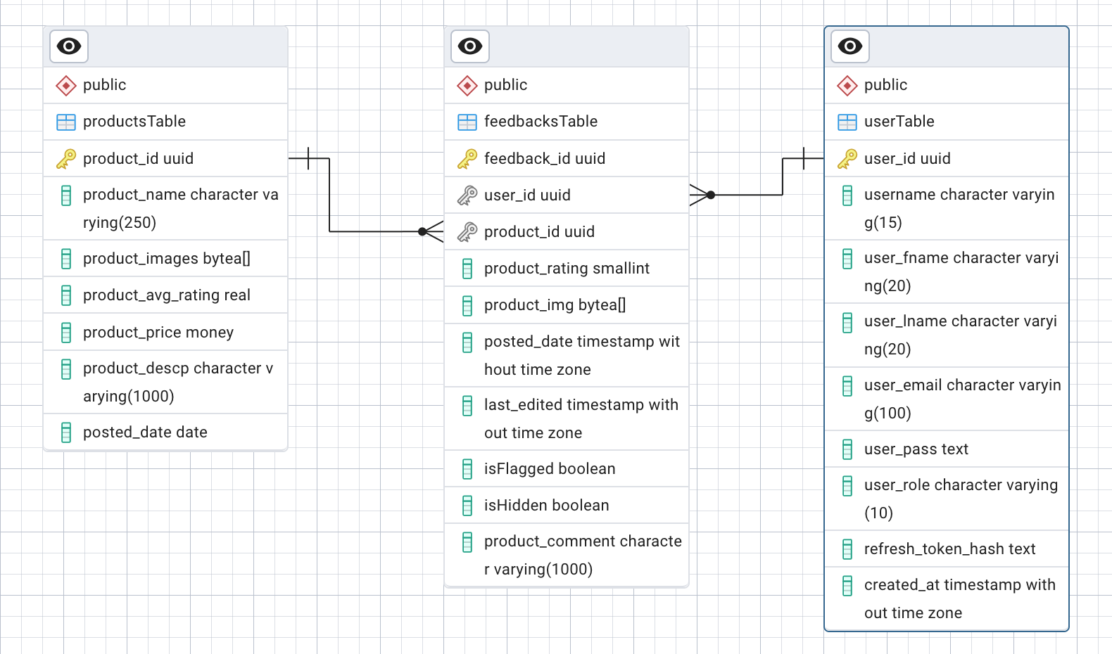

Figure 1.1 Entity Relational Diagram for Tables (PostgreSQL)